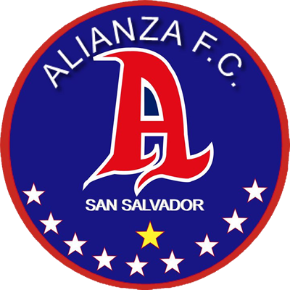 | ALIANZA | (1) | KNOCKOUT STAGES | (2) | COMUNICACIONES | 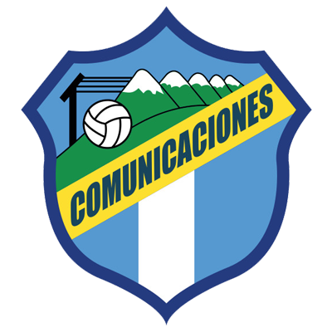

 | SEPTEMBER 29 |  | 8:15 PM ET |  | Cuscatlán Stadium

ALIANZA FC vs. COMUNICACIONES FC
Carlos Castrillo and José Corena of Comunicaciones FC have two yellow cards.
Comunicaciones defeated Alianza FC 2-1 (Andrés Lezcano and Junior Lacayo; Duvier Riascos) in the first leg of the R16 at the Doroteo Guamuch Flores Stadium in Guatemala City (22-SEP).
It will be the 4th duel between rivals from El Salvador and Guatemala in the Concacaf League.
Guatemalans never lost. Matches: Comunicaciones vs.Once Deportivo (1-1 and 0-3) in the 2021 Preliminary Round, and Comunicaciones vs. Alianza (2-1) in R16 2021.
It will be the 19th match in the SCL at theEstadio Cuscatlán in San Salvador.
Alianza scored goals in their 7 Concacaf League games in this stadium where they do not know defeat (5W-2T):
Results: 2-1 to Platense (R16 2017), 1-0 to Olimpia (QF 2017), 5-1 to San Francisco (Preliminary Round 2019), 2-0 to Tauro (R16 2019), 2-0 to San Carlos (QF 2019), 1-1 vs. Motagua (SF 2019) and 1-1 (3-4 defeat on penalties) vs. Motagua (R16 2020).
 | ALIANZA (SLV)
FOUNDED: 1958. COACH: Milton Meléndez (SLV), 54 years old.
PARTICIPATIONS: 4 (2017, 2019, 2020 and 2021). BEST RESULT: Semi-finals in 2019.
RECORD: GP-14 W-7 T-2 L-5 (GF-19 GA-15).
TOP SCORERS: Rodolfo Zelaya (SLV) and Raúl Peñaranda (SLV) with 4 goals.
ASSISTS: Luis Hinestroza (COL) 3, Marvin Monterroza and Héctor Ramos with 2.
SAVES IN SCL 2021: (0). GOALKEEPERS: Yimy Cuellar.
TOTAL SAVES: (41). GOALKEEPERS: Rafael García (URU) with 41.
PENALTY DEFINITIONS: (1). WON: 0. LOST: 1.
- Defeat 3-4 vs. Motagua in the R16 of the 2020 edition after drawing 1-1 in the single match at the Cuscatlán stadium.
TOP PLAYERS:
- Rodolfo Zelaya (SLV). He has scored 4 goals with Alianza FC in 6 games and 1 assist). He has played in 2017, 2020 and 2021. He had 3 finishes vs Comunicaciones.
- Duvier Riascos (COL). He scored Alianza's goal in the first leg. The South American striker took 5 shots vs. Communications.

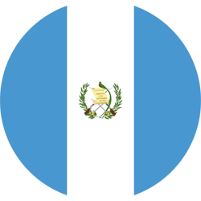 | COMMUNICATIONS (GUA)
FOUNDED: 1949. COACH: Willy Coito (URU).
PARTICIPATIONS: 3 (2019, 2020 and 2021). BEST RESULT: 2019 Quarterfinals.
RECORD: GP-10 W-4 T-5 L-1 (GF-11 GA-8).
TOP SCORERS: Rafael Lezcano (CRC) with 3 goals, Gerardo Gordillo (GUA), Agustín Herrera (MEX), Junior Lacayo (HON) with 2.
ASSISTS: Maximiliano Lombardi (ARG) and Rafael Lezcano (CRC) 2. with 1, Lynner García, Jorge Aparicio, José Corena and Juan Luis Anangonó.
SAVES IN SCL 2021: (11). GOALKEEPERS: Kevin Moscoso (GUA) with 11.
TOTAL SAVES: (27). GOALKEEPERS: José Calderón (PAN) with 16 and Kevin Moscoso (GUA) with 11.
PENALTY DEFINITIONS: (1). WON: 0. LOST: 1.
- Lost in his only dispute in penalties in the historic series 15-14 against Motagua in the Preliminary Round of the 2020 edition after drawing 2-2 in regulation time.
TOP PLAYERS:
- Andrés Lezcano (CRC). He has scored three goals in SCL He is the team's top scorer and has 2 assists.
- Kevin Moscoso (GUA). The goalkeeper made 9 saves (accumulates 11 saves in 2021).
- Júnior Lacayo (HON) came on as a substitute in the second half and scored the winning goal for his team. Lacayo has scored two goals in the SCL.

