COMUNICACIONES FC vs. FC MOTAGUA

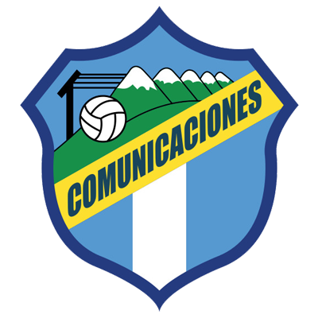 | COMUNICACIONES  (GUA) | (2) | FINAL | (1) | MOTAGUA  (HON) | 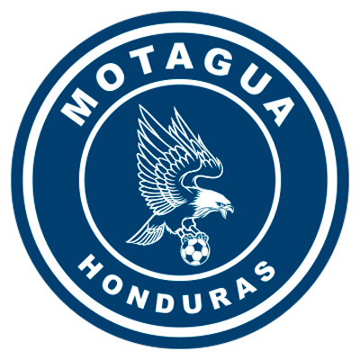

 | DECEMBER 14 |  | 9:00 PM ET |  | DOROTEO GUAMUCH FLORES, GUATEMALA
Comunicaciones FC won (2-1) in the first leg (Roberto Moreira for Motagua; Jorge Aparicio and Juan Luis Anangonó for Comunicaciones FC) at the Estadio Nacional in Tegucigalpa.
In the previous match they drew (2-2) in the preliminary round on October 22, 2020 at the Estadio Nacional in Tegucigalpa. Andrés Lezcano and Augustín Herrera scored for Comunicaciones, Matías Galvaliz and Kevin López scored for Motagua. In the definition of penalties, Motagua won 14-15 and advanced to the knockout stages.
Of the 36 shots, 29 were scored and 7 were missed. For Motagua failed Kevin López, Juan Pablo Montes and Emilizo Izaguirre and Alejandro Galindo, Gerardo Gordillo (2) and Kevin Grijalva for Comunicaciones.
Motagua and Comunicaciones have faced each other six times in KO´s series in four of them, Motagua managed to advance.
Tuesday's match will be thesixteenth between Motagua and Comunicaciones, of which, the Catracho club has four wins,20 goals for and 14 against, two wins for Comunicaciones and nine draws.
The first match between Motagua and Comunicaciones was in the former 1986 Concacaf Champions Cup in the second round of Central American Group 2.
The first leg was played in Guatemala City drawing 1-1 Oscar Girón scored for Comunicaciones and Manuel Chavarría for Motagua.
Motagua lost for the first time in a first leg vs. Communications in direct elimination series (1-1) in 1986 (1-1) in 1991, (1-2) in 1992 and (0-0) in 1998, fell 2-1 in 2021.
Motagua managed to advance in the 1986 Concacaf Champions Cup, 1992 Central American Tournament, 1998 Central American Grand Tournament and 2020 Scotiabank Concacaf League.
The only time Comunicaciones eliminated Motagua was in the 1991 Torneo Centroamericano.
To date, 15 matches have been played at the Estadio Nacional Doroteo Guamuch Flores. .
It will be the 8th match between clubs from Guatemala and Honduras in the SCL
Guatemala clubs have two wins, four draws and one loss
Comunicaciones (84) and Motagua (76) are the clubs with the most goal situations in this edition of the Concacaf League.
Motagua is the team with the most shots in the SCL (31), and Comunicaciones FC the one that has scored the most goals (17).

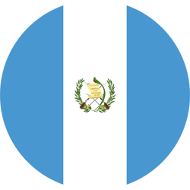 | COMUNICACIONES (GUA)
- RECORD IN SCL: GP-16 W-9 T-5 L-2 (GF-24 GA-16).
- TOP SCORERS IN THE HISTORY OF SCL: Andrés Lezcano (CRC) 6, Júnior Lacayo (HON) and Óscar Santis (GUA) 3 each, Juan Luis Anangonó (ECU) (3), Gerardo Gordillo (GUA) and Agustín Herrera (MEX) 2 each.
- TOTAL SAVES IN SCL: (48). GOALKEEPERS: José Calderón (PAN) 16 and Kevin Moscoso (GUA) with 32.
- SAVES IN SCL 2021: (32). GOALKEEPERS: Kevin Moscoso (GUA) 32.
- Never lost in a second leg: 7 GP 4W-3T
- Comunicaciones has won 4 decisive matches in the SCL 2021: 1-3 vs. Once Deportivo SLV (Preliminary Round), 0-1 vs. Alianza SLV (R16), 2-1 vs. Dep. Saprissa CRC (QF) and 2-1 vs. Guastatoya GUA (SF).
- It is the Guatemalan club with the most appearances (3), matches (16), wins (9) and goals (24) in the history of the SCL.
- He scored goals in 81.3% of Concacaf League matches. Comunicaciones did not score in the goalless draws vs. Guastatoya -GUA- (R16 2019) and Olimpia -HON- (QF 2019) and in the 2-0 defeat vs. Olimpia -HON- (QF 2019).

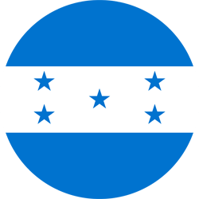 | MOTAGUA (HON)
- RECORD IN THE SCL: GP-27 W-12 T-10 L-5 (GF-37 GA-24).
- TOP SCORERS IN THE HISTORY OF SCL: Kevin López (HON) 8, Rubilio Castillo (HON), Roberto Moreira Aldana (PAR) 6, Juan Pablo Montes (HON) with 5 goals.
- TOTAL SAVES: (67). GOALKEEPERS: Jonathan Rougier (ARG) with 64 and Marlon Licona (HON) with 3.
- SAVES IN SCL 2021: (20). GOALKEEPERS: Marlon Licona (HON) with 3 and Jonathan Rougier (ARG) with 17.
- Motagua has never lost a second leg in the history of the Concacaf League: 11GP 6W-4T
- The 3 times Motagua lost in the first leg, managed to score points in the second leg: 2 wins and 1 draw (vs. Tauro PAN in SF 2018, vs. Herediano CRC in the 2018 Final and vs. Dep. Saprissa CRC in the 2019 Final).
- Maintained their unbeaten fence in the last 6 second legs in SCL: 0-0 vs. Waterhouse JAM (QF 2019), 3-0 vs. Alianza SLV (SF 2019), 0-0 vs. Saprissa CRC (Final 2019), 1-0 vs. Universitario PAN (R16 2021), 2-0 vs. Marathón HON (QF 2021) and 0-0 vs. Forge CAN (SF 2021).
- If they win the second leg, Motagua will overtake Deportivo Saprissa (CRC) as the team with the most wins in SCL history with 13.
- It is the first team to have qualified for three 3 SCL finals (2018, 2019 and 2021).
- He scored goals in 80.8% of his Concacaf League matches. He has the best record of matches with goals scored (21) in the SCL.
- 100% of the goals scored (36) were scored by Honduran footballers (24), Argentina (6) and Paraguay (6).
- He kept the fence undefeated 44.4% of the matches in SCL (12 of 27). It is the team with the highest number of undefeated hurdles (12) in the history of SCL. In turn, it is the team that more games without scoring goals (6).
- The team with the most games tied (10). Together with Forge FC (CAN) they are the teams that drew the most games without goals (3).
- Motagua has managed to score goals in 21 matches and only in 6 matches could not score goals.
- Motagua is unbeaten in his 3 away matches at the SCL 2021 (1G-3E) and managed to score goals in all matches.

TOP PLAYERS
- Andrés Lezcano (CRC) / Comunicaciones FC. He is the top scorer in the 2021 SCL with (5). He has a total of 6 goals and 3 assists in 12 appearances in SCL history.
- Oscar Santis (GUA) / FC Communications. He is the only player to have score a Hat-Trick in SCL 202 vs. Deportivo Saprissa (CRC) in the first leg's Quarter-Finals). The player with his teammate Juan Anangonó with more shots (15) in the SCL 2021.
- Juan Luis Anangonó (ECU) / Comunicaciones FC. He has scored 3 goals and has 3 assists in 9 P's in the SCL. TheSCL has played (744') minutes and shot3 times in the first leg.
- Kevin Moscoso (GUA) / FC Comunicaciones. He has played 774 minutes and is the goalkeeper with the most saves (32) in the SCL 2021. Moscoso had 4 saves in the first leg.
- Kevin Lopez (HON) / FC Motagua. He is the scorer (8) and matches played (27) with Motagua in the SCL. Lopez holds the overall record for most matches in SCL history (27) and is the second highest scorer in the history of the contest (8) behind Johan Venegas (CRC) with 14.
- Omar Elvir (HON) / FC Motagua. He has played (672) minutes in the 2021 SCL and is the player with the most correct passes with (294).
- Matías Galvaliz (ARG) / FC Motagua. He is one of the leaders in assists in the history of the SCL with (6).
- Roberto Moreira (PAR) / FC Motagua. He was the player with the most shots in the first leg with (4).
- Jonathan Rougier (ARG) / FC Motagua. He contributed 2 saves in the first leg.
- Juan Delgado (HON) / FC Motagua. He was the player with the most fouls in the first leg (5). He is the player with the most balls recovered in the SCL 2021 with (21) and with the most shots on goal (6)
- Iván López (HON) / FC Motagua. He made a shot and was the second player with the most goal situations of Motagua (3) vs. Comunicaciones.

