RECORD IN SCL FINALS
In 5 of the 6 editions of Concacaf League, at least one team from Costa Rica participated in the finals of the contest: Santos de Guápiles (2017), Herediano (2018), Saprissa (2019), Saprissa and Alajuelense (2020) and Alajuelense (2022).

Similarly, in 5 of the 6 editions of SCL, at least one representative of Honduras was present at the finals: CD Olimpia (2017 and 2022), FC Motagua (2018, 2019 and 2021).

The scorers in the finals have been: Costa Rica (9), Honduras (6), Ecuador (4), Paraguay (2) and Guatemala (1).

To date, 9 matches have been played in the Concacaf League finals between 2017, 2018, 2019, 2020* and 2021. *The 2020 final was a single match and was held in 2021 after the suspension of the tournament due to the COVID-19 pandemic.

The goal average in the finals is 2.44. 22 goals and a total of 15 assists were scored.

It will be the 6th match in the history of the SCL at the José de la Paz Herrera Uclés stadium, since its name change in 2022. In the previous 5 matches, the home team did not lose or concede goals (3-W-2-D). FC Motagua wins 2-0 vs. Cibao FC, CD Olimpia 1-0 vs. Deportivo Municipal (R16 - 2022) and CD Olimpia 1-0 vs. FC Motagua (SF - 2022); draws between FC Motagua 0-0 Tauro FC (QF - 2022) and FC Motagua 0-0 CD Olimpia (SF - 2022).

It will be the fourth match of a Scotiabank Concacaf League final at the National Stadium in Tegucigalpa, Honduras: FC Motagua won 2-1 vs. Herediano in 2018, a 0-0 draw between FC Motagua and Deportivo Saprissa in 2019 and a 1-2 loss of FC Motagua vs. Comunicaciones FC on 2021.

The 2021 Final between Comunicaciones FC (GUA) and FC Motagua (HON) is where more goals have been scored in the history of the SCL (9) (1-2 in the first leg and 4-2 in the second leg). In 2018, 5 goals were scored between Herediano vs. FC Motagua (3-2) and Alajuelense vs. Deportivo Saprissa in 2020 (3-2).

Comunicaciones FC (GUA) was the only team to win all 2 games in an SCL final series. The Guatemalans beat (1-2) and (4-2) FC Motagua (HON) in the 2021 final.

The only time a team was able to overcome an adverse score and achieve the title was CD Olimpia in 2017 after losing 0-1 in the first leg in San Pedro Sula against Santos de Guápiles (CRC), won in the second leg 1-0 and then 4-1 in penalty kicks.

Whenever a team won the first leg of a final playing at home, they were crowned champion in the SCL. Herediano (CRC) vs. FC Motagua (HON) in 2018 -2-0 victory in the first leg and defeat 2-1 in the second leg and Deportivo Saprissa (CRC) vs. FC Motagua (HON) in 2019 won 1-0 in the first leg and 0-0 in the second leg.

There has only been a draw in the SCL finals (0-0) between Motagua and Saprissa, in the second leg in 2019. The rest were 5 wins for the home teams and 3 away wins.

Since the final of the SCL 2017 that the title is not defined in penalty kicks. Olimpia beat Santos de Guápiles of Costa Rica 4-1 at the National Stadium in San Jose, Costa Rica after a 1-1 draw on aggregate.

To date, no goals have been scored in 6 SCL finals matches. Deportivo Saprissa (CRC) was the only champion who did not receive goals in their 2 matches of a final: in 2019 vs. FC Motagua (HON), 1-0 in the first leg and 0-0 in the second leg.

Juan Anangonó (ECU) is the top scorer in the SCL finals (4 goals and 2 assists with Comunicaciones FC in 2021). the Ecuadorian was the only player to score a hat-trick in a final (vs. FC Motagua on 14-DEC-2021). Roberto Moreira (PAR), Rubilio Castillo (HON) and Jimmy Marín (CRC). They have scored 2 goals in a final.

Alexander Lopez (Honduras), Johan Venegas (Costa Rica) of Alajuelense and Michaell Chirinos (Honduras) of Olimpia, could become the only players in SCL history to score for the second time in a final. López, would impose a record to achieve it, after having scored with Olimpia in 2017 and now as a player of LD Alajuelense.

To date, no penalty kick has been scored in the SCL finals or own goals.

72.7% of the goals were from plays (16), 5 headed goals and 1 from free kicks.

Rubilio Castillo (HON) was the only player to score a brace in a final (vs. Herediano in 2018 with FC Motagua in just 12 minutes.

Kevin López (HON) is the leader of assists in the finals of the SCL: 4, followed by: Juan Luis Anangonó (ECU), Adrián Martínez (CRC) and José Guillermo Ortíz (CRC) 2. Lopez made 2 assists for FC Motagua.

Kevin López (HON) playing for Comunicaciones FC in 2021 and Adrián Martínez (CRC) of Alajuelense in 2020 were the assists leaders in the same match of an SCL final with (2).

Yurguin Román (CRC) scored the only free kick goal in an SCL final. The left-back in Alajuelense's 3-2 win vs. Saprissa in 2020. Roman holds the record of being the only one to score in an SCL final.

So far, 44 yellow cards have been shown in the SCL finals: 9 (2017), 13 (2018), 9 (2019), 4 (2020) and 9 (2021).

The only 2 sent off (1 direct red card for Juan Delgado of Motagua 2020 vs Comunicaciones and 1 for double yellow card for Yostin Salinas of Saprissa in 2019 vs Motagua).

Roberto Moreira (PAR) player of Motagua scored the fastest goal in an SCL final. The Paraguayan scored a header at 3 minutes with 39 seconds in the second leg vs. FC Communications on 14-DEC-2021.

Marvin Angulo (CRC) scored the latest goal in a final in the 86th minute 6 seconds for Saprissa (CRC) vs LD Alajuelense on 3-FEB-2021.

Jimmy Marin (CRC) is the youngest goalscorer in the history of the SCL finals at 21 years and 17 days. The striker scored the first goal in Herediano's 2-0 vs. Motagua win in 2018, at the Eladio Rosabal Cordero stadium, CRC (OCT 25, 2018). Marin also scored the goal that gave CS Herediano the title in the second leg in the 2-1 defeat.

Christian Bolaños (CRC) is the oldest player to score in a fine 36 years, 8 months and 14 days in Saprissa's 3-2 loss vs. Alajuelense (CRC) at Alejandro Morera Soto Stadium (Feb 3, 2021).

PLAYERS TO FOLLOW
- Edrick Menjívar, CD Olimpia. He is the leader in saves (36) in 577 minutes (he has only conceded 3 goals and in 4 games he did not allow goals). Menjivar has 47 saves in 12 matches between (2017, 2019, 2020, 2021 and 2022) and was champion 2017 with CD Olimpia, where he only had action vs. Alianza FC of El Salvador in the Quarterfinals.
- Leonel Moreira, LD Alajuelense. Winner 2 times of the Gold Glove in 2018 with CS Herediano and 2020 with LD Alajuelense, he is the only goalkeeper in the history of the SCL to achieve it. In 2018 as a CS Herediano player, he made 22 saves in 663 minutes and did not concede goals in 3 games and with LD Alajuelense he has 12 saves in 375 minutes and has not conceded goals in 2 games.
- Miguel Ajú has played 3 matches in SCL 2022, with 11 saves and did not concede goals in 1 match.

DEFENDERS
- Juan Pablo Montes, CD Olimpia. He was runner-up 2 times in (2018, 2019, 2022) as captain of FC Motagua. To date he has played in 23 games and has scored 5 goals being the defender with the most goals in the history of the SCL.
- Aubrey David (Trinidad and Tobago) Alajuelense. He is the defender with the most recovered balls in the SCL 2022 with (9). He has played in 44 matches in Concacaf club tournaments between (SCCL, SCL and FCCCC). He was champion in 2019 with Deportivo Saprissa (playing in 8 games) and runner-up in 2020 (4 games). He has been in 3 SCL finals (2019 and 2020 with Saprissa, and 2022 with Alajuelense).

HISTORICAL IN SCL
- Michaell Chirinos, CD Olimpia. Champion in 2017 and scorer of the goal in the 1-0 win vs. Santos de Guápiles in the second leg that tied the series and forced penalty kicks. Chirinos has 8 assists and 6 goals.
- Alexander López, Alajuelense. He has been champion with two different teams, in 2017 with CD Olimpia where he was elected in the Ideal XI of the tournaments in 8 games and 1 goal and with LD Alajuelense in 2020 (5 games and 1 goal) where he won the Golden Ball award. Lopez has 6 assists in SCL history.

FORWARDS
- Jerry Bengtson: CD Olimpia the Olimpia captain has scored 2 goals and 9 shots in 320 minutes in the 2022 SCL. In 14 matches, Bengtson has scored goals for CD Olimpia: 2019 (1), 2020 (1), 2021 (1) and 2022 (2).
- Johan Venegas: Alajuelense. He is the top scorer in the history of the SCL (16 goals and 4 assists in 18 games between Saprissa and Alajuelense). He was the top scorer in 2019 (6) and 2020 (7) champion with Saprissa, scoring the only goal in the 2019 final vs FC Motagua.

REVELATIONS, PROMISES
- Josmán Figueroa: CD Olimpia. The 21-year-old midfielder has played 101 minutes. He had participation vs. Municipal (Eighth Finals) and Diriangén (Quarterfinals). He has 1 assist, 79% efficiency in passes (33 complete). He played in 3 matches in the SCCL (2020 and 2021).
- José Mario Pinto: CD Olimpia. He has played in 9 SCL matches (2020, 2021 and 2022) and 7 SCCL matches. He has been selected U-20 of Honduras in the Concacaf Championship Costa Rica 2017 and U-23 in the Concacaf Olympic Qualifier for Tokyo 2020. With the senior team, he played in the Concacaf qualifiers for Qatar 2022 and Concacaf Nations League.
- Jorge Álvarez: CD Olimpia. He was part of the roster that won the SCL title in 2017. He has played in 3 games in the SCL. He has been selected U-17 (FIFA World Cup Chile 2015), U-20 (Concacaf Championship Costa Rica 2017 and FIFA World Cup Korea Republic 2017), U-23 (Olympic Games Tokyo 2020) and in the (Gold Cup 2019, Concacaf Qatar 2022 qualifiers and CNL 2019/20)
- Doryan Rodriguez: Alajuelense. He is the top scorer for Alajuelense in the 2022 SCL with (3). He scored a hat-trick vs. Alianza FC PAN in the Round of 16).
- Bryan Félix (Honduras) Alajuelense: The player born in San Pedro Sula, is the youngest scorer of the SCL 2022 with 19 years, 6 months and 27 days vs. CD Águila of El Salvador in the preliminary round (1-1). The 5 matches played have been as a substitute.
- Aaron Suarez: Alajuelense: He has 10 international goals in Concacaf and 2 goals scored vs. CD Águila and Alianza FC were in the SCL 2022 in 7 matches. He is one of the players with the most shots (16) and more passes (309) in Alajuelense. He was part of the team that won the title in 2020.

VETERANS
- Boniek García: CD Olimpia The 38-year-old midfielder has played in 5 games in the SCL 2022 (271), scored 1 goal, 1 assist and 98 passes. He played in 28 matches in the SCCL.
- Brayan Moya: CD Olimpia. He has scored 2 goals and 1 assist in 457 minutes in the 2022 SCL. He has made 9 shots and 51 correct passes. Champion in 2017 with CD Olimpia, (scored a goal in the penalty shootout vs. Santos de Guápiles, has played 14 games in the SCL and 2 goals scored.
- Celso Borges: Alajuelense. He has 8 goals and has scored 1 goal in the 3-0 win vs. Real España in the first leg of the 2022 Semifinals. To date he has 260 correct passes (89%). With 154 games, he is the player with the most appearances in the Costa Rican National Team.
- Bryan Ruiz: Alajuelense. Champion in the SCL 2020. He has played in 9 matches in the SCL between (2020, 2021 and 2022) and has scored 1 goal. With the Costa Rican National Team, he has played 145 games and scored 29 goals.
TOP 3 | 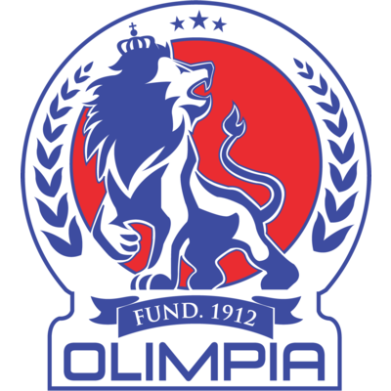

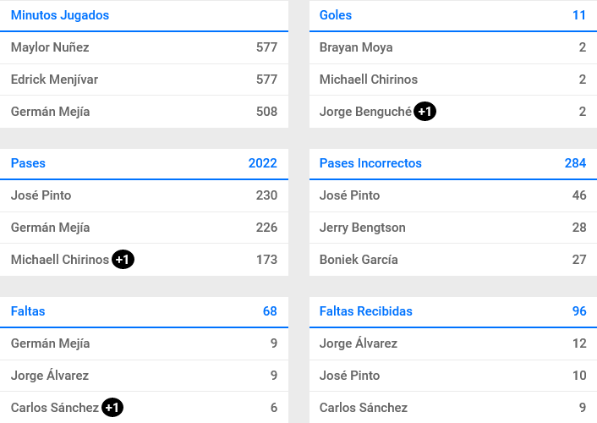
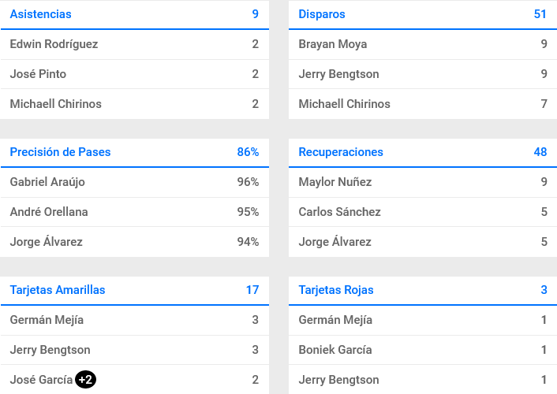

TOP 3 | 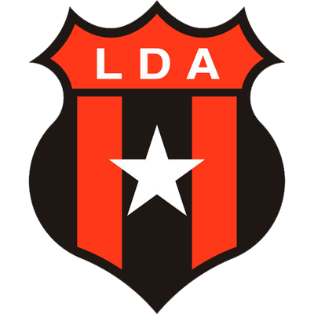

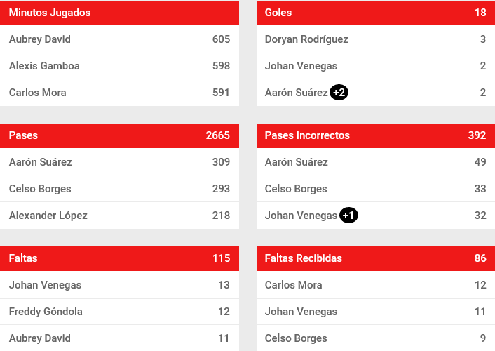
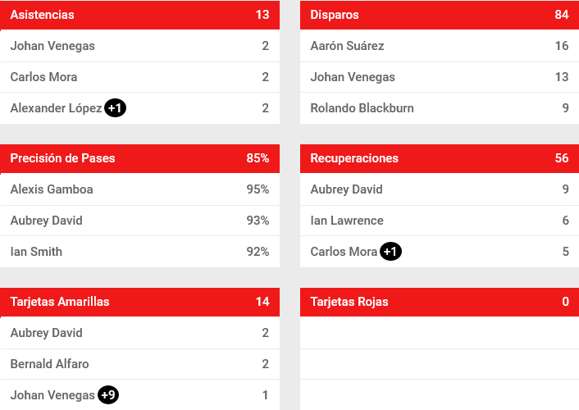

SCL 2022

 | STATISTICS
11 | GOALS FOR | 18
3 | GOALS CONCEDED | 4
9 | ASSISTS | 13
51 | GOAL SITUATIONS | 84
15 | SHOTS ON TARGET | 30
4 | SHOTS AT THE POLES | 1
21 | DEFLECTED SHOTS | 35
21.6 | SHOOTING EFFECTIVENESS (%) | 21.4
32 | SAVES | 23
68 | FOULS COMMITTED | 115
96 | FOULS RECEIVED | 86
48 | RECOVERIES | 56
55 | RIVAL RECOVERIES | 74
1738 | CORRECT PASSES | 2273
284 | WRONG PASSES | 392
86 | EFFECTIVENESS IN PASSES (%) | 85.3
22 | CORNER KICKS | 28
6 | OFFSIDES | 18
15 | YELLOW CARDS | 14
6 | MATCHES PLAYED | 8
14 | POINTS | 18

DATA IN THE SCL

SUMMARY

HISTORICAL
49 | GOALS FOR | 30
14 | GOALS CONCEDED | 13
33 | ASSISTS | 21
24 | MATCHES PLAYED | 17
15 | VICTORIES | 9
5 | DRAWS | 6
4 | DEFEATS | 2
35 | GOAL DIFFERENCE | 17
85 | SAVED | 47
14 | CLEAN SHEETS | 8
3 | 0-0 DRAWS | 1
5 | PARTICIPATIONS | 4
1 | BEST FINISH | 1
2 | FINALS | 2
2 | DEFINITION BY PENALTIES | 1
1 | PENALTIES WON | 1
18 | GAMES WITH GOAL | 14
10 | GAMES WITH GOAL CONCEDED | 9
2.1 | GOAL AVERAGE | 1.9
69.4 | TOURNAMENT EFFICIENCY (%) | 64.7
50 | ACCUMULATED POINTS | 33

AWARDS
2017
Golden Boot: Roger Rojas (HON) - Olimpia (HON) 5 goals
Ballon d'Or: Michaell Chirinos (HON) - Olimpia (HON)
Gold Glove: Bryan Morales (CRC) Santos de Guápiles (CRC)
Best Young Player: Kevin Alvarez (HON) - Olimpia (HON)
Fair Play Award: Santos de Guápiles (CRC)
2018
Golden Boot: Rubilio Castillo (HON) - Motagua (HON) 5 goals
Ballon d'Or: Yendrick Ruíz (CRC) - Herediano (CRC)
Gold Glove: Leonel Moreira (CRC) - Herediano (CRC)
Best Young Player: Jimmy Marín (CRC) - Herediano (CRC)
Fair Play Award: Motagua (HON)
2019
Golden Boot: Johan Venegas (CRC) - Saprissa (CRC) 7 goals
Ballon d'Or: Johan Venegas (CRC) - Saprissa (CRC)
Gold Glove: Jonathan Rougier (ARG) - Motagua (HON)
Best Young Player: Manfred Ugalde (CRC) - Saprissa (CRC)
Fair Play Award: Saprissa (CRC)
2020
Golden Boot: Johan Venegas (CRC) - Saprissa (CRC) 6 goals
Ballon d'Or: Alexander López (HON) Alajuelense (CRC)
Gold Glove: Leonel Moreira (CRC) Alajuelense (CRC)
Best Young Player: Fernán Faerron (CRC) Alajuelense (CRC)
Fair Play Award: Alajuelense (CRC)
2021
Golden Boot: Juan Luis Anangonó (ECU) - Comunicaciones FC (GUA) 6 goals
Ballon d'Or: Juan Luis Anangonó (ECU) - Comunicaciones FC (GUA)
Gold Glove: Kevin Moscoso (GUA) Comunicaciones FC (GUA)
Best Young Player: Oscar Santis (GUA) Comunicaciones FC (GUA)
Fair Play Award: FC Communications (GUA)

FINALS HISTORY

2017
CD Olimpia HON (Champion) and Santos de Guápiles CRC (Runner-up)
First Leg:
 | Metropolitan Olympic, San Pedro Sula | Olimpia | 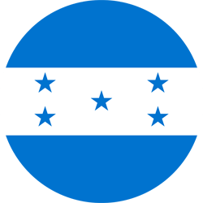 | 0 | Santos |  | 1
Second leg:
 | National of Costa Rica | Santos |  | 0 (1) | Olimpia |  | 1 (4)

2018
Herediano CRC (Champion) and FC Motagua HON (Runner-up)
First leg:
 | Eladio Rosabal Cordero | Herediano |  | 2 | Motagua |  | 0
Second leg:
 | National Stadium | Motagua |  | 2 | Herediano |  | 1

2019
Saprissa CRC (Champion) and FC Motagua HON (Runner-up)
First leg:
 | Ricardo Saprissa Aymá Stadium | Saprissa |  | 1 | Motagua |  | 0
Second leg:
 | National Stadium | Motagua |  | 0 | Saprissa |  | 0

2020
Alajuelense CRC (Champion) and Dep Saprissa CRC (Runner-up)
SINGLE PARTY:
 | Alejandro Morera Soto Stadium | Alajuelense |  | 3 | Saprissa |  | 2

2021
Communications FC GUA (Champion) and FC Motagua HON (Runner-up)
First leg:
 | National Stadium | Motagua |  | 1 | Comunicaciones | 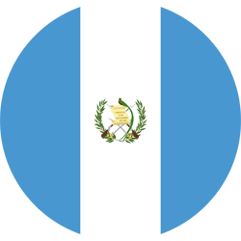 | 2
Second leg:
 | Doroteo Guamuch Flores Stadium | Comunicaciones |  | 4 | Motagua |  | 2

