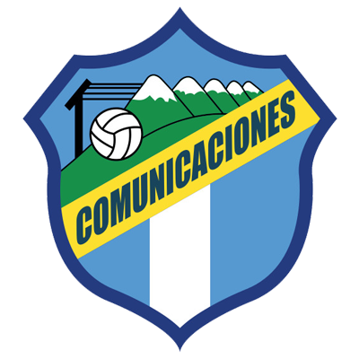 | COMUNICACIONES |  | R16 |  | ALIANZA | 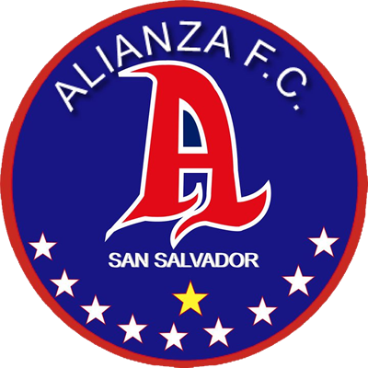

 | SEPTEMBER 22 |  | 8 PM ET |  | Doroteo Guamuch Flores Stadium

DATA

COMUNICACIONS vs. ALIANZA FC
They will meet for the first time in the Scotiabank Concacaf League.
It will be the third match between rivals of Guatemala and El Salvador in the Concacaf League all in the Preliminary Round of this edition: Comunicaciones vs. Once Deportivo (1-1 and 0-3).
The 9th SCL match will be played at the Mateo Flores National Stadium. Comunicaciones played 4 times at home in this stadium: 2-1 vs Marathón (Preliminary Round 2019), 2-1 vs Guastatoya (R16 2019), 0-0 vs. Olimpia (QF 2019) and 1-1 vs. Once Deportivo (Preliminary Round 2021). In addition, and as a visitor vs. Guastatoya in the Guamuch Flores in R16 2019 (0-0).
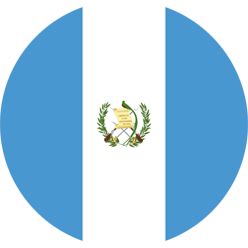 | COMMUNICATIONS (GUA)
FOUNDED: 1949.
COACH: Willy Coito (URU).
PARTICIPATIONS: 3 (2019, 2020 and 2021).
RECORD: GP-9 W-3 T-5 L-1 (GF-11 GA-8).
TOP SCORERS: Gerardo Gordillo (GUA), Agustín Herrera (MEX) and Rafael Lezcano (CRC) 2 goals.
ASSISTS: Maximiliano Lombardi (ARG) and Rafael Lezcano (CRC) 2, with 1, Lynner García, Jorge Aparicio.
SAVES IN SCL 2021: (2). GOALKEEPERS: Kevin Moscoso (GUA) with 2.
SAVES IN THE SCL: (18). GOALKEEPERS: José Calderón (PAN) with 16 and Kevin Moscoso (GUA) with 2
PENALTY DEFINITIONS: (1). WON: 0. LOST: 1.
- Lost on penalty kicks (15-14) vs. Motagua in the Preliminary Round of the 2020 edition after drawing 2-2 in regulation time. It is the longest penalty shootout in Concacaf club tournament history.
TOP PLAYERS:
- José Manuel Contreras (GUA). He played in the SCL 2020 (1 match) and in 2021 (2 games). Contreras played for Guatemala four games and scored one goal in the Gold Cup (2007), in 2011 (two games) and in 2015 (two matches)
- Andrés Lezcano (CRC). He has scored 2 goals and 1 assist in the SCL. He scored a goal against Motagua (HON) in the 2020 Preliminary Round and Once Deportivo (SLV) in the 2021 Preliminary Round. In addition, he played in 2018 with Antigua (GUA).
 | ALIANZA (SLV)
FOUNDED: 1958.
COACH: Milton Meléndez (SLV).
PARTICIPATIONS: 4 (2017, 2019, 2020 and 2021).
BEST RESULT: Semifinals in 2019.
RECORD: GP-13 W-7 T-2 L-4 (GF-18 GA-13).
TOP SCORERS: Rodolfo Zelaya (SLV) and Raúl Peñaranda (SLV) with 4 goals.
ASSISTS: Luis Hinestroza (COL) 3, Marvin Monterroza and Héctor Ramos with 2.
SAVES IN SCL: (41). GOALKEEPERS: Rafael García (URU) with 41.
PENALTY DEFINITIONS: (1). WON: 0. LOST: 1.
- Lost 3-4 vs. Motagua in the R16 SCL 2020 after drawing 1-1 in a single match at the Cuscatlán Stadium.
THUS QUALIFIED TO SCL 2021: Champion of the Apertura 2020 Tournament of the First Division of El Salvador with the best aggregate record of the 2020/21 Season. Advanced directly to the 2021 SCL Knockout Stages.
TOP PLAYERS:
- Rodolfo Zelaya (SLV). He is the Salvadoran player with the most goals scored in the Scotiabank CONCACAF League: (4) goals and an assist with Alianza FC in 5 matches. Zelaya played in the SCL (2017) and (2020)
- Jonathan Jimenez (SLV). He has 10 SCL appearances between (2017, 2019 and 2020) with Alianza FC. He scored 1 goal in 7 games as they advanced to the Semi-Finals in 2019.
- Marvin Monterroza (SLV). He has played 12 matches in the SCL between (2017, 2019, 2020) He was elected to the Ideal XI at the SCL 2019 where he scored two goals.

