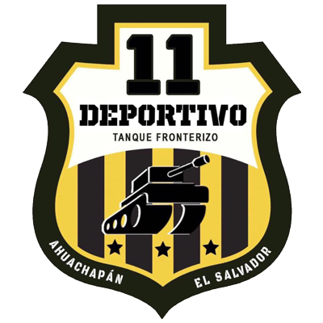 | 11 DEPORTIVO | (1) | PRELIMINARY ROUND | (1) | COMUNICACIONES | 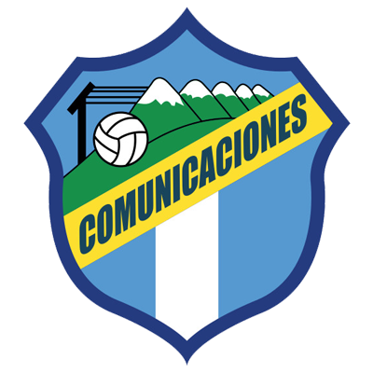

 | AUGUST 19 |  | 10:00 PM ET |  | Cuscatlan

DATA
Only twice, the home teams that drew in the first leg in SCL history advanced to the next stage.
Robinhood (SUR) vs. AS Capoise (HAI). Preliminary round (2019) Robinhood advanced by away goal rule 0-0 in the first leg and 1-1.
Waterhouse FC (JAM) knockouts 2019 vs CS Herediano. Waterhouse FC advanced on penalty kicks (6-7) after drawing 1-1 on aggregate.
11 Deportivo became the 48th team to debut and the sixth from El Salvador in SCL history.
11 Deportivo is the sixth club in the history of the SCL that managed to draw in its debut and the first from El Salvador to do so.
They drew (1-1) in the first leg (Alexander Larín Comunicaciones and Edgar Medrano for Once Deportivo), Estadio Doroteo Guamuch Flores of Guatemala City (5 AUG 2021). This was the fourth tie in 7 games in SCL history at The Doroteo Guamuch Flores Stadium.
For Comunicaciones, it was the third consecutive draw in the history of the SCL in 8 matches where it has two wins, five draws and one loss.
15 SCL matches have been played at the Estadio Cuscatlan of El Salvador, four were from the Preliminary Round: Alianza vs San Francisco (2019), FAS vs Managua (2020) Municipal Limeño vs Forge (2020), Forge FC vs FAS 2021.

 | 11 DEPORTIVO (SLV)
FOUNDED: 2019.
COACH: Carlos Romero (SLV), 55 years old.
Participations: 1 (2021).
RECORD: GP1 W-0 T-1 L-0 (GF-1 GA-1).
GOAL SCORERS: Edgar Medrano (COL) 1.
ASSIST LEADERS: Craig Foster (JAM) 1.
SAVES IN 2021: Yonatan Guardado (SLV) 3.

TOP PLAYERS:
- Edgar Medrano (COL). He scored the first goal in history for Once Deportivo in Scotiabank Concacaf League. The Colombian midfielder had 2 shots.
- Craig Foster (JAM). He played 32 minutes in the first leg and provided the assist on the tying goal vs. Comunicaciones. The 29-year-old forward has played for, Sweden, Finland, the United States, El Salvador, and Costa Rica.
- Melvin Cartagena (SLV). He had two shots, (49 correct passes) eight recovered balls and received six fouls vs. Comunicaciones
 | COMUNICACIONES (GUA)
FOUNDED: 1949.
COACH: Willy Coito (URU), 50 years old.
PARTICIPATIONS: 3 (2019, 2020 and 2021).
RECORD: GP-8 W-2 T-5 L-1 (GF-8 GA-8).
GOAL SCORERS: Gerardo Gordillo (GUA), Agustín Herrera (MEX) 2 goals.
ASSISTS LEADERS: Maximiliano Lombardi (ARG) 2.
SAVES IN SCL 2021: Fredy Pérez (GUA) has no saves
SAVES IN THE HISTORY OF SCL: (16): José Calderón (PAN) 16.
DEFINITIONS BY PENALTIES: (1). WON: 0. LOST: 1. Lost (15-14) vs FC Motagua of Honduras in the Preliminary Round in 2020 after a 2-2 in regulation time. That's the longest penalty shootout in the history of a Concacaf club tournament.
TOP PLAYERS :
- Alexander Larín (SLV). He scored the 19th goal for a Salvadoran player in SCL history and the second on his tally (in 2017 he had scored playing for Alianza FC against Platense FC of Honduras in the knockout stages in 2017.
- Juan Luis Anangonó (ECU). He fired 2 shots in his 2021 SCL debut. The Ecuadorian attacker has played in Argentina, the United States, Mexico, China, Paraguay and Bolivia, as well as Barcelona SC, El Nacional and LDU Quito.

- Rafael Morales (GUA). He has 21 matches in Concacaf club tournaments. He played 7 matches in Concacaf League (2019 and 2021). In addition, 14 appearances in Scotiabank Concacaf Champions League (2011/12, 2013/14, 2014/15, 2016/17 and 2020) with Comunicaciones and Deportivo Saprissa.

