Round of 16
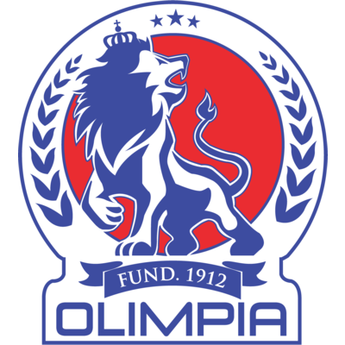 |  |  | 25 de agosto |  | 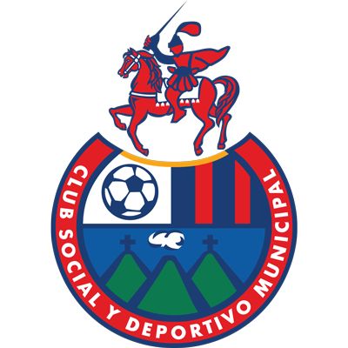
 |  |  | 10:30 PM EDT
CD OLIMPIA  (HON) |  |  | Chelato Uclés |  | CSD MUNICIPAL  (GUA)

CD Olimpia vs. CSD Municipal
They tied (2-2) in the first leg on August 18, 2022 goals by Municipal Eduardo Rotondi (penalty) and Yasnier Matos; by Olimpia Brayan Moya and Boniek García.
It will be the 10th match between teams from Honduras and Guatemala in the SCL, the Guatemalans have 3-W 5-D and 1-L
Olimpia and Municipal met in the former Concacaf Champions Cup (1970, 1973, 1989) and in the UNCAF Interclub Cup (1996.97, 1997-98), 1999-2000, 2002-01, 2003-04, 2005-06)
ALL-TIME SERIES: Municipal wins the series: G-19 W-6 D-8 L-4 GF-18 GA-18.
First leg game facts
The match between Municipal and CD Olimpia was the second game with the most cards in the history of the Scotiabank Concacaf League (7 yellow cards and 2 red cards). Previously, 11 cards had been shown in the match 11 Deportivo from El Salvador and Comunicaciones with 9 yellow cards and 2 red cards in 2011.

Teams with the most red cards in SCL history: CD Olimpia (5), Comunicaciones (4) Walter Ferretti (3), Forge FC (3), Honduras Progreso (2).

Bryan Moya (CD Olimpia) scored the 4th fastest goal by a Honduran player and the 3rd fastest headed goal in SCL history.

Boniek Garcia became the 1st player in SCL history to score in his first match and receive a red card.

CD Olimpia has achieved three of the wins with the most goals scored in SCL history: 1-7 vs. Plaza Amador in 2017, 6-0 vs. Managua in 2020 and 0-6 vs. Inter Moengotapoe from Suriname in 2021.
It is the second team with the most games played in the history of the SCL (19).
Municipal is the team with the most goals scored (11) shots (58) and passes (1,162) in the 2022 SCL.
CD OLIMPIA
RÉCORD EN SCL: G-19 W-11 D-4 L-4 (GF-40 GA-13).
TOP SCORERS: Roger Rojas (HON) 5, Carlo Costly (HON) 4, Michaell Chirinos (HON) 4.
ASSIST LEADER: Michaell Chirinos (HON) 6, Alexander López (HON) 3, Roger Rojas (HON), Edwin Rodríguez (HON) y Jorge Álvarez (HON) 2.
PLAYERS WITH MOST MATCHES: Éver Alvarado (HON), Germán Mejía (HON), Michaell Chirinos (HON) 11, Jerry Bengtson (HON) 10, Jorge Benguché (HON), Edwin Rodríguez (HON), Brayan Moya (HON) 9.
SAVES: 64 GOALKEPERS: Edrick Menjívar (HON) 26, Donis Escober (HON) 19, Harold Fonseca (HON) 19. CLEAN SHEETS: 10.
RECORD IN R16: G-7 W-5 D-1 L-1 (GF-21 GA-4).
SCORERS IN R16: Jerry Bengtson (HON) 3, Eddie Hernández (HON), Edwin Rodríguez (HON) 2.
ASSITS LEADER IN R16: Michaell Chirinos (HON) 4, Edwin Rodríguez (HON) 2.
CD OLIMPIA IN R16: They advanced three times defeating LD Alajuelense 2-0 and 1-0 in 2017, lost 0-1 against Forge FC of Canada in the first leg and won 4-1 at home in 2019, defeated 6- 0 to Managua in 2020.
PENALTY SHOOT OUTS: (2). WIN: 1. LOST: 1.
They won (4-1) in the final in 2017 against Santos de Guápiles after drawing (1-1) on aggregate and lost (4-5) against LD Alajuelense after drawing (0-0) in a single match in the semifinals in 2020.
CD OLIMPIA EN SCL: Has not scored goals in 5 games, has not conceded goals in 10 games and has scored goals in 14 games.
RECORD IN SECOND LEG GAMES: G-7 W-4 D-2 L-1.
MOST SCORING WINS IN SCL: 1-7 vs. Plaza Amador of Panama, (Ervin Zorrilla; Carlo Costly, Alexander López, Roger Rojas x2, Michaell Chirinos x2 and Jesús Canales) in the Semifinals in 2017, 6-0 vs. Managua (Elvin Oliva, Michaell Chirinos, Yustin Arboleda, Edwin Rodríguez, Jerry Bengtson and Marvin Bernárdez) round of 16 in 2020 and 0-6 vs. Inter Moengotapoe from Suriname (Jerry Bengtson, Carlos Pineda, Edwin Rodríguez, Diego Reyes and Eddie Hernández x2) Round of 16 2021.
BRACES (5): Carlo Costly HON vs. Alianza (QF 2017), Roger Rojas HON and Michaell Chirinos vs. Plaza Amador of Panamá (SF 2017), Jorge Benguché vs. Saprissa (SF 2019) and Eddie Hernández vs. Inter MT Suriname (R16 2021). HAT TRICKS: 0
TOP PLAYERS

Edwin Rodriguez (HON). He provided one goal assist and completed 85% of the passes in the first leg (20 passes in total). The midfielder has scored 2 goals and has 2 assists in his last 5 SCL games.

Brayan Moya (HON). He has played in 9 matches in the SCL. He scored Olimpia's first goal in the first leg in a 2–2 draw.

Edrick Menjivar (HON). He made 11 saves and 10 clearances in the first leg. Menjivar was the goalkeeper with the most saves in the first legs.

CSD MUNICIPAL

RECORD IN SCL: G-4 W-2 D-1 L-1 (GF-12 GA-6).
TOP SCORERS: Eduardo Rotondi (ARG) 3, John Méndez (GUA), Antonio López (MEX), Rudy Barrientos (GUA), Milciades Portillo (PAR), Ramiro Rocca (ARG), José Martínez (GUA), César Archila (GUA), Marlon Sequen (GUA), Yasnier Matos (CUB) 1.
ASSIST LEADER: Rudy Barrientos (GUA) 2, José Carlos Martínez (GUA), César Archila (GUA), Eduardo Rotondi (ARG) 1.
PLAYERS WITH MOST MATCHES: Jaime Alas (SLV), José Rosales (GUA), José Morales (GUA), Rudy Barrientos (GUA), José Carlos Martínez (GUA) 4, Steve Makuka (URU), Milciades Portillo (PAR), Eduardo Soto (GUA), Ricardo Jerez (GUA), Luis Martinez (GUA), John Mendez (GUA), Eduardo Rotondi (ARG) 3.
SAVES: 8. GOALKEEPERS: Rafael García (URU) 4, Ricardo Jerez (GUA) 4. CLEAN SHEETS: 1.
RECORD IN R16: G-2 W-0 D-1 L-1 (GF-3 GA-5).
SCORERS IN R16: Ramiro Rocca (ARG), Eduardo Rotondi (ARG) Yasnier Matos (CUB) 1.
ASSISTS IN R16: Eduardo Rotondi (ARG) 1.
CSD MUNICIPAL IN R16: It was eliminated the only time it played in the round of 16 by Deportivo de Saprissa in a single match (1-4) at the Ricardo Saprissa stadium on November 6, 2020. Johan Venegas scored 4 goals and Ramiro Rocca scored for municipal.
RECORD IN SECOND LEG MATCHES: G-1 W-1 D-0 L-0.
SCORES: 5-0 to Vega Real DOM (Antonio López, Eduardo Rotondi, Rudy Barrientos, Milciades Portillo and John Méndez) (4-AUG, 2022). It is Municipal's best result in the SCL.
TOP PLAYERS
Eduardo Rotondi (ARG). He is the team's top scorer in the SCL (3 goals and 1 assist).
Jose Carlos Martinez (GUA). He is one of the players with the most shots along with his teammate Eduardo Rotondi with (11). He scored a goal and was the player with the most shots (8) vs Atlético Vega Real.
Jose Rosales (GUA). He has played all 4 games for Municipal in the SCL. He was the player with the most passes (91) 88 completed in the first leg. Along with his teammate, the Uruguayan Steve Makuka were the players with the most balls recovered (3) in the first leg.

