Preliminary Round
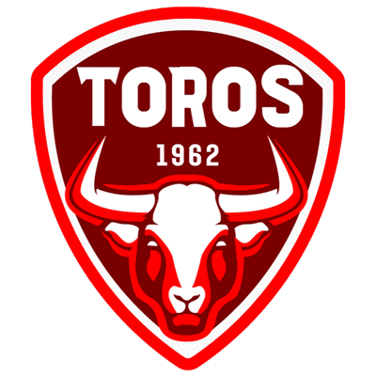 |  |  | July, 27 |  | 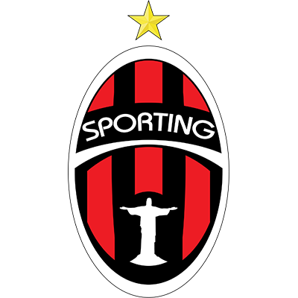
 |  |  | 8:00 PM ET
MALACATECO  (GUA) |  |  | Estadio Pensativo |  | SP. SAN MIGUELITO (PAN)

Malacateco vs. Sporting San Miguelito

SERIES AT SCOTIABANK CONCACAF LEAGUE: They will meet for the first time

Teams from Guatemala and Panama in SCL: G-1 W-0 D-1 L-0 GF-0 GA-0.

It will be the second matchup between a team from Guatemala and Panama in the SCL, the previous one was (0-0) in regulation time between Club Atletico Independiente CAI (PAN) and Antigua (GUA) in a single match in the Preliminary Round in 2020, Malacateco won 4- 2 on penalty kicks.

MALACATECO

SCL APPEARANCES: 1 (2022 DEBUT).

HOW DO THEY QUALIFIED FOR THE 2022 SCL: after winning Guatemalan football’s 2021 Apertura, the club’s first ever domestic title.

Malacateco will debut in the Scotiabank Concacaf League.

➔ It is one of the 7 debuting teams in the 2022 edition with Atlético Vega (DOM), Platense (SLV), Pacific (CAN), Cartaginés (CRC), Sporting San Miguelito and Alianza (PAN).

➔ It will be the 6th team from Guatemala to play in the SCL. The others have been Comunicaciones FC -Champion in 2022-, Guastatoya, Santa Lucía, Antigua and Deportivo Municipal.

➔ Only 2 Guatemalan teams managed to win matches in SCL history. Comunicaciones FC (10 wins) and Santa Lucía (2).

➔ Enzo Herrera (URU) is one of Malacateco's top scorers. The Uruguayan striker scored 12 goals in 38 appearances in the 2021/22 Season in Guatemala.

SPORTING SAN MIGUELITO

APPEARANCES IN SCOTIABANK CONCACAF LEAGUE: 1 (2022 DEBUT).
HOW DO THEY QUALIFIED FOR THE 2022 SCL: Sporting San Miguelito became the eighth different team from Panama to qualify for the SCL as the non-champion with the best aggregate record in 2021-22 season.
Sporting San Miguelito will make its debut in the SCL.
➔ It is one of the 7 debuting teams in the 2022 edition with Malacateco (GUA), Atlético Vega (DOM), Platense (SLV), Pacific (CAN), Cartaginés (CRC), and Alianza (PAN).
➔ The other teams from Panama in the SCL are: Tauro, Árabe Unido, Universitario, Plaza Amador, San Francisco, CAI and Alianza FC. Árabe Unido is the Panamanian team with the most games (12) and wins (7) in the SCL between (2017 and 2018).
➔ It will be the 50th match of a team from Panama in the SCL. In the previous 49 games they achieved 19 wins, 8 draws and 22 losses.
➔ Luis Zúñiga (PAN) was Sporting San Miguelito's top scorer in the 2022 Torneo Apertura (6 goals).
➔ Adolfo Machado, was champion with Alajuelense in the 2020 SCL. He faced Cibao (Preliminary Round), San Francisco (Round of 16) and Real Estelí (Quarter Finals) and was the player with the most passes with a (96%).

