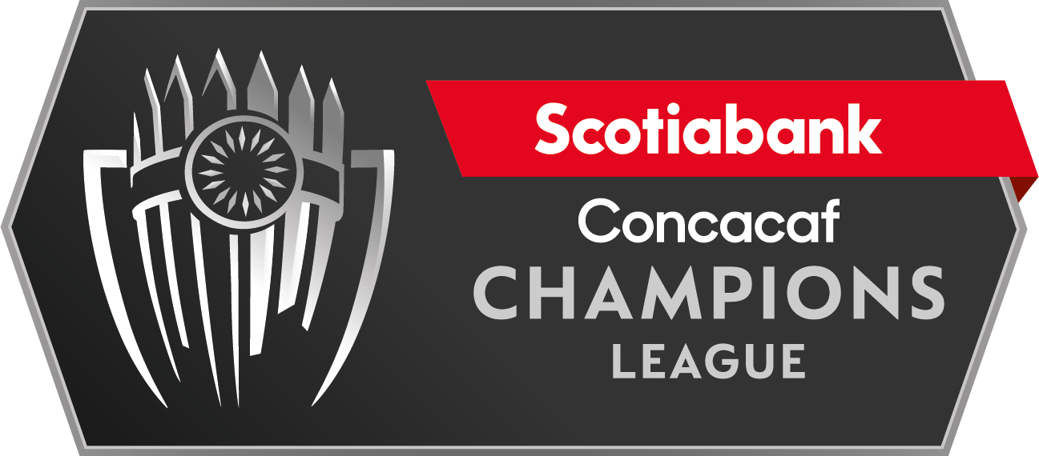

Tigres UANL vs. Orlando City
 |  |  | March 7 |  | 
 |  |  | 10 PM ET
Tigres UANL |  |  | Estadio Universitario |  | Orlando City

It will be the first time they meet in the Concacaf Champions League.
Series between clubs from the United States vs. Mexico (Champions Era):
Teams from the United States vs. Mexico clubs: G-93 W-24 D-17 L-52.
Teams from Mexico vs. United States clubs: G-93 W-52 D-17 L-24.

Tigres UANL 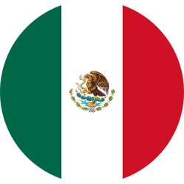
PARTICIPATIONS IN THE SCCL: 10th (1979, 1981, 1983, 2012/13, 2015/16, 2016/17, 2018, 2019, 2020, 2023).
DEBUT: 1979 (Semifinalist).
SCCL RECORD (includes Concacaf Champions Cup): G: 56 W-29 D-14 L-13 (GF-101 GA-93)
HOME RECORD: G: 29 W-21 D-6 L-2 (GF-64 GA-19)
LAST PARTICIPATION: Champion 2020.
BEST RESULTS: Champion (2020), Runner-up (2015/16, 2016/17, and 2019).
SCCL RECORD ERA: G: 44 W-24 D-10 L-10 (GF-81 GA-40)
SCCL ERA SCORERS: André-Pierre Gignac (FRA) 14, Enner Valencia (ECU) 10, Eduardo Vargas (CHI) 7, Alan Pulido (MEX) 4
HAT-TRICKS IN SCCL ERA: Alan Pulido (MEX) vs. Alajuelense CRC (Group 6 - 2012/13). Enner Valencia (ECU) vs. Saprissa CRC (R16 - 2019). Alonso Zamora, André Gignac x4, Enner Valencia x2, and Jürgen Damm recorded a brace
PLAYERS WITH THE MOST CAPS IN THE SCCL ERA: Jesús Dueñas (MEX) 36, Hugo Ayala (MEX) 32, Nahuel Guzmán (ARG) 32, Jorge Torres Nilo (MEX) 26, Guido Pizarro (ARG) 26, Javier Aquino (MEX) 25.
HOW DID THEY CLASSIFY FOR THE SCCL 2023? Non-finalist of the Clausura 2022 Tournament with the most points accumulated during the Liga MX season.
PARTICIPATIONS IN THE ROUND OF 16 (SCCL ERA): 2018 (eliminated Herediano CRC), 2019 (eliminated Saprissa CRC), 2020 (eliminated Alianza FC SLV).
RECORD IN THE ROUND OF 16 (SCCL ERA): G: 6 W-3 D-1 L-2.
QUALIFICATIONS TO THE QUARTER-FINAL (SCCL ERA): 2012/13 (vs. Seattle Sounders), 2016/17 (vs. Pumas UNAM), 2018 (vs. Toronto F.C.), 2019 (vs. Houston Dynamo) and 2020 (New York City).
SCORERS IN THE ROUND OF 16 (SCCL ERA): Enner Valencia (ECU) 6, André-Pierre Gignac (FRA) 2.
AWAY RECORD (SCCL ERA): G: 15 W-6 D-4 L-5.
In 2020 Tigres UANL was crowned champion with the best records in terms of goals (15), shots (86), and assists (10).
Games vs. USA teams: Seattle Sounders (Q.F. 2012/13), Real Salt Lake (Q.F. 2015/16), Houston Dynamo (Q.F. 2019), New York City (Q.F. 2020), and Los Angeles FC (Final 2020). His only loss: was vs. Seattle Sounders 3-1 (DeAndre Yedlin, Djimi Traoré, and Eddie Johnson; Elías Hernández) in the 2012/13 Q.F. second leg (March 12, 2013).
Tigres UANL was runner-up in 2015/16, 2016/17, and 2019. vs. Club América (2015/16): defeat 0-2 (Darío Benedetto and Osvaldo Martínez) at the Universitario stadium, MEX (April 20, 2016); and 2-1 loss (Michael Arroyo and Osvaldo Martínez; André-Pierre Gignac), at the Azteca stadium, MEX (April 27, 2016). vs. Pachuca (2016/17): 1-1 (Víctor Ismael Sosa; Raúl López), at the Universitario stadium, MEX (April 18, 2017); and defeat 1-0 (Franco Jara), at the Hidalgo stadium (April 26, 2017). vs. Monterrey (2019): 0-1 loss (Nicolás Sánchez) at the Universitario stadium, MEX (April 23, 2019); and 1-1 (Nicolás Sánchez and André-Pierre Gignac), at the BBVA Bancomer stadium, MEX (May 01, 2019).
Won the last five games in the SCCL: 4-2 vs. Alianza FC SLV (Enner Valencia, André Gignac x2 and Nahuel Guzmán; Juan Portillo) in R16 2020, vs. New York City USA in Q.F.: 1-0 (Eduardo Vargas), and 4-0 (André-Pierre Gignac, Leonardo Fernández, Rafael De Souza and Javier Aquino); vs. Olimpia HON in S.F.: 3-0 (André-Pierre Gignac x2 and Elvin Oliva e/c) and vs. Los Angeles FC USA in the 2020 Final: 2-1 (Hugo Ayala and André-Pierre Gignac; Diego Rossi).
TOP PLAYERS
André-Pierre Gignac (FRA) was the top scorer in 2020 (6 goals and two assists). The French forward was the leader in shots with (30) and shots on goal (15). He was runner-up in 2015/16, 2016/17, and 2019. He also was a Runner-up in the CONMEBOL Libertadores 2015.
Luis Quiñones (COL) led in assists in 2019 and 2020 (3), along with fellow Colombian Dorlan Pabón from Monterrey.
Nahuel Guzmán (ARG) was the goalkeeper with the most minutes on the pitch (571') and 11 saves. In the 2018 Round of 16, he scored a goal against Alianza of El Salvador. Guzman has 89 saves in the SCCL to date. In 2019, he played 757 minutes and made 28 saves.

Orlando City 
PARTICIPATIONS IN SCCL: 1 (2023)
DEBUT: 2023
YEAR FOUNDED: November 19, 2013.
HOW DID THEY CLASSIFY FOR THE 2023 SCCL? 2022 U.S. Champion Open Cup defeating the Sacramento Republic in the final.
Orlando City will be the 19th team from the USA to participate in the SCCL.
Orlando City Head Coach is Colombian Oscar Pareja, who led FC Dallas to the 2016-17 SCCL semifinals.
TOP PLAYERS
Facundo Torres (URU) was one of the scorers in the 2022 U.S. Open Cup with (4).
Pedro Gallese (PER) is the starting goalkeeper for the Peru team. He has played in 93 matches and the 2018 FIFA World Cup in Russia. In Major League Soccer's final season in 2022, he made 80 saves in 33 appearances.
Felipe Martins (BRA) participated in 4 editions of the SCCL in 2013/14 and 2014/15 with F.C. Montreal (6 games) and 2016/17 and 2018 with New York Red Bull (7 games).

