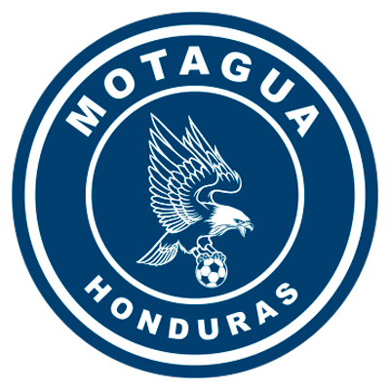 | MOTAGUA | (2) | QUARTERFINALS | (0) | MARATHON | 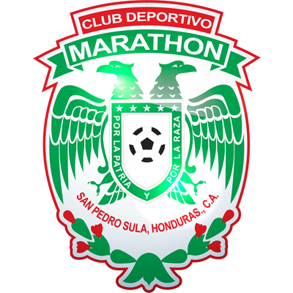

 | NOVEMBER 2 |  | 10:15 PM ET |  | TIBURCIO CARÍAS ANDINO

MOTAGUA vs. MARATHON
Motagua won 2-0 against Marathón in the first leg (DiegoAuzqui and Gonzalo Klusener) Estadio Olímpico Metropolitano de San Pedro Sula (21/OCT).
Defeat vs. Motagua was second for CD Marathon in 7 home matches.
Motagua's 2-0 vs CD Marathon win was the 11th for coach Diego M Vázquez (ARG) to place him in first place among the coaches with the most wins in the SCL.
They faced each other in Group C of the 2002 UNCAF Interclub Cup victory (2-1) of Motagua (José Pacini x2; Emil Martínez), Estadio Nacional, Tegucigalpa (3/NOV/2002).
The last time CD Marathon defeated FC Motagua at the National Stadium in Tegucigalpa was (2-1) on 27-11-2016 second leg of the Torneo Apertura playoff, (Diego Reyes 45+3 and Jairo Puerto 88 for Marathon, Rubilio Castillo 90+3 for Motagua. Carlos Pavón was the coach of CD Marathon and Diego Vázquez de Motagua.
14 Concacaf League matches have been played at the Estadio Nacional in Tegucigalpa. Motagua (8), Olimpia (4 and Marathón (2).
Marathón played 2 times at home at the National Stadium for not being able to play at its home field in San Pedro Sula: defeat 0-2 vs. Saprissa -CRC- (QF 2020) and 1-0 triumph to Forge -CAN- (Repechage for the SCCL 2021).
 | MOTAGUA (HON)
APPEARANCES: 4 (2018, 2019, 2020 and 2021). BEST RESULT: Runner-up in 2018 and 2019.
Whenever they won the first leg in the SCL he was never eliminated.
RECORD IN SCL: GP-23 W-11 T-8 L-4 (GF-32 GC-20). 59.4% effectiveness.
TOP SCORERS: Kevin Lopez (HON) 7. Then, Rubilio Castillo (HON) Juan Pablo Montes (HON) 5, Roberto Moreira Aldana (PAR) 3.
SCORERS IN QF: Rubilio Castillo (HON) 3 and Juan Pablo Montes (HON) 2.
ASSISTS IN SCL: Matías Galvaliz (ARG) 6 -leader in the Concacaf League-, Kevin López (HON) 4.
QF ASSISTS: Kevin Lopez (HON) 2, Omar Elvir (HON), Wilmer Crisanto (HON)1 C/U.
TOP SCORERS BY YEAR: Rubilio Castillo (HON) 5 in 2018, Juan Pablo Montes (HON) 2 in 2019, Matías Galvaliz (ARG) and Kevin López (HON) 2 in 2020, Kevin López (HON) 2 in 2021.
PLAYERS WITH MOST PRESENCES: Kevin López (HON) 23 games,Walter Martínez (HON) and Jonathan Rougier (ARG) with 21, Roberto Moreira (PAR) and Matías Galvalíz (ARG) 19.
HAT TRICKS: 0
BRACES (4): Juan Pablo Montes (HON) vs. Portmore United in QF 2018, Rubilio Castillo (HON) vs. Portmore United in QF 2018, Rubilio Castillo (HON) vs. Herediano in the 2018 Final (the club's fastest in SCL with 12 minutes), and Kevin Lopez (HON) vs. Universitario in R16 2021.
YOUNGEST SCORER: Denil Maldonado (HON) with 21 years, 2 months and 26 days in the triumph (1-2) vs. Managua in the R16 of 2019 (21/AUG/2019).
OLDEST SCORER: Gonzalo Klusener (ARG) 38 years in the win (2-0) vs Marathón (21/OCT). The striker marked his 38th birthday.
FASTEST GOAL: Juan Pablo Montes at 3 minutes with 25 seconds in the draw(1-1) vs. Alianza FC in the Semifinals of 2019 (24/OCT/2019).
HOW THEY HAVE SCORED: 18 of play, 9 headers, 4 of penalty and 1 own goal (he has not scored from a free kick).
TOTAL SAVED: (57). GOALKEEPERS: Jonathan Rougier (ARG) 54 and Marlon Licona (HON) 3. Jonathan Rougier is the goalkeeper with the most saves in SCL history (54). Saved 1 penalty in the historical definition (15-14) vs. Communications for the Preliminary Round 2020, and 2 against Alliance in R16 2020. He made 4 saves vs. Marathón in the first leg of QF 2021.
SAVES IN SCL 2021: (10). GOALKEEPERS: Marlon Licona (HON) 3 and Jonathan Rougier (ARG) 7.
PENALTY DEFINITIONS: (3). WON: 2. LOST: 1.
- Won (15-14) vs Communications in the 2020 Preliminary Round after drawing (2-2) in regulation time and (4-3) vs. Alliance in the 8th of Final 2020.
- Lost (4-2) vs. Real Estelí after drawing (2-2) in the Repechage for the SCCL 2021 at the National Stadium.
FC Motagua has managed to score goals in 18 matches, only in 5 failed to score, 10 hurdles undefeated, in 13 matches conceded goals,2 draws (0-0).
It is the team with most goals in Concacaf League (18) Equaled Olimpia with 10 games keeping a clean sheet in SCL.
It is the team with the most tied matches in the Concacaf League (8).
TOP PLAYERS
- Kevin Lopez (HON). He is the top scorer in the SCL 2021 (2) was runner-up in 2018 and 2019, is the player with the most matches in the history of the club (23) and goals scored (7).
- Iván López (HON). He was the Motagua player with the most shots vs. Marathón (2). He has played 5 matches in SCL: (2) with Real España in 2018 and (3) with Motagua in 2021.
- Diego Auzqui (ARG). He scored the first goal vs Marathon. He has played 233 minutes and has received two yellow cards.
- Gonzalo Klusener (ARG). The Argentine striker has played 8 international matches (6) and SCCL (2) and scored 1 goal. He has faced Marathón 8 times and never lost: 6PG-2PE (He scored 3 goals).

MARATHÓN (HON)
PARTICIPATIONS: 3 (2019, 2020 and 2021). BEST RESULT: Quarterfinals 2020.
RECORD IN SCL: GP-10 W-4 T-2 L-4 (GF-9 GA-11). 46.7% effectiveness.
TOP SCORERS: Edwin Solano (HON) and Mario Martínez (HON) 2. , Yustin Arboleda, Allan Banegas, Frelys López, Brayan Castillo, Kervin Arriaga 1 c/u.
GOALS IN QF: 0.
ASSISTS IN SCL: Mario Martínez (HON) 2.
ASSIST IN QF: 0.
SCORERS BY YEAR: Edwin Solano (HON) and Yustin Arboleda (COL) 1 in 2019, Allan Banegas (HON), Edwin Solano (HON) 1 in 2020, Mario Martínez (HON) 2 in 2021.
PLAYERS WITH MOST PRESENCES: Edwin Solano (HON), Mathías Techera (URU), Denovan Torres (HON) and Luis Garrido (HON) 8, Frelys López (HON) and Carlo Costly (HON) 6.
HAT TRICKS: 0
BRACES: 0
YOUNGEST SCORER: Brayan Castillo (HON) with 23 years, 3 months and 18 days in the win (2-0) vs. Real Estelí in R16 of 2021 (23/SEP/2021).
OLDEST SCORER: Mario Martínez (HON) with 32 years, 1 month and 24 days in the triumph (2-0) vs Real Estelí in R16 of 2021 (23/SEP/2021).
FASTEST GOAL: Edwin Solano at 3 minutes with 59 seconds in the 2-1 vs. Comunicaciones loss in the 2019 Preliminary Round (1/AUG/2019).
HOW THEY SCORED IN SCL: 6 of play, 2 of penalty and 1 of free kick.
TOTAL SAVES IN SCL: (22). GOALKEEPERS: Denovan Torres (HON) 18 and Luis Ortiz (HON) 4.
SAVES IN SCL 2021: (13). GOALKEEPERS: Denovan Torres (HON) 13.
PENALTY DEFINITIONS: (2). WON: 2. LOST: 0.
- Won (4-3) vs. Antigua (GUA) in the 2020 SCL Knockout Round after drawing 1-1 in regulation time and vs. Real Estelí (NCA) (5-4 ) after drawing 2-2 on aggregate in R16 in 2021.
Has 7 games in which they scored goals, in 3 they could not score goals, 3 undefeated fences, 7 matches with goals conceded.
Whenever they lost the first leg, he was eliminated. Comunicaciones in the 2019 Preliminary Round after losing (2-1) in the first leg and drawing (1-1) in the second leg (round trip).
TOP PLAYERS :
- Kervin Arriaga (HON). He was the player with the most shots vs. Motagua (3). He has faced Motagua 9 times (he scored 1 goal in the Honduran National League 2019).
- Carlos Costly (HON). The 39-year-old veteran has 19 club international appearances and has scored 7 goals. He was champion of the Concac fScotiabank League 2017 with Olimpia scoring 4 goals in 6 appearances.
- Ovid Lanza (HON). He fired 2 shots vs. Motagua. He played 5 Concacaf League matches with Olimpia (1 in 2019) and Marathón (4 in 2021).
- Denovan Torres (HON). He has played 8games in the SCL and adds (18 saves). In 2021 he has made 13 saves in 482 minutes. He saved (2) penalties vs. Antigua -GUA- in R16 2020) and (4) vs. Real Estelí in R16 2021). He is the goalkeeper with the most penalties saved in the history of the SCL (6).

