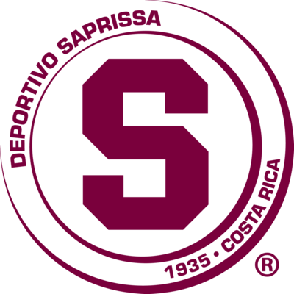 | DEPORTIVO  SAPRISSA | (2) | KNOCKOUT STAGES | (0) | SANTA LUCIA C. | 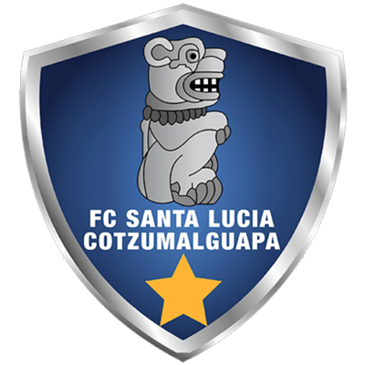

 | SEPTEMBER 30 |  | 8 PM ET |  | Ricardo Saprissa Aymá

DEPORTIVO SAPRISSA vs. SANTA LUCIA C.
Deportivo Saprissa defeated Santa Lucía (Chirstian Bolaños and Kendall Watson) 2-0 in the first leg at the Estadio Doroteo Guamuch Flores in Guatemala City (23-SEP).
It will be the 5th game between a team from Costa Rica and one from Guatemala in the Concacaf League. Deportivo Saprissa has won all the matches: they beat Municipal 4-1 (Johan Venegas x4; Ramiro Rocca) in the R16 2020 Estadio Ricardo Saprissa Aymá. Then, defeated Santa Lucía C. (Chirstian Bolaños and Kendall Watson) 2-0 first leg of the 2021 SCL Knockout Stage at the Estadio Doroteo Guamuch Flores in Guatemala City. The other meetings were in the 2021 knockout stages between Alajuelense and Guastatoya.
It will be the 10th match of the Concacaf League at the Ricardo Saprissa Aymá Stadium. Santos (2 games) and Dep. Saprissa (7 ) The local teams never lost. Saprissa beat Belmopan Bandits 3-1 (2019 Preliminary Round), Águila (R16 2019), CAI (QF 2019), Olimpia (SF 2019), 1-1 Against Motagua (Final 2019), 4-1 against Municipal (R16 2020) and 5-0 against Arcahaie (SF 2020).
 | DEP. SAPRISSA (CRC)
FOUNDED: 1935. COACH: Wilber Weight (CRC), 50 years old.
PARTICIPATIONS: 3 (2019, 2020 and 2021). BEST RESULT: Champion in 2019.
RECORD: GP-15 W-11 T-1 L-3 (GF-32 GA-12).
It is the team with the best goal average scored in the history of the Concacaf League (2.13).
They have won 7 matches playing at home in the SCL.
TOP SCORERS: Johan Venegas (CRC) with 13 goals (All-time top scorer in SCL), Manfred Ugalde (CRC), Christian Bolaños (CRC) with 4 and Marvin Angulo (CRC) with 3.
ASSISTS: Marvin Angulo (CRC) 4, Randall Leall, Michael Barrantes with 3, Johan Venegas, Christian Bolaños and Mariano Torres with 2.
SAVES IN SCL 2021: (0). GOALKEEPERS: Aaron Cruz (CRC). He kept the fence undefeated in the first leg vs. Santa Lucia C.
TOTAL SAVES: (17). GOALKEEPERS: Aaron Cruz (CRC) with 17.
DEFINITIONS BY PENALTIES: no.
Players with a yellow card: Jimmy Marín, Néstor Mariano Torres, David Guzmán.
TOP PLAYERS :
- Mariano Torres (ARG). The team captain was champion in the SCL 2019 and Runner-up in 2020 with Deportivo Saprissa. The Argentine midfielder gave an assist in the first leg of R16 vs. Santa Lucía (he had 2 assists in the history of the SCL).
- Cristian Bolaños (CRC). At 37 years, 4 months and 6 days he became the oldest player to score in an SCL Knockout game. The Saprissa (CRC) player scored the 2-0 win vs. Santa Lucia C. (GUA) in the first leg and surpassed the record held by his teammate Michael Barrantes at 36 years and 11 months.

 | SANTA LUCIA C. (GUA)
FOUNDATION: 1992. COACH: Mario Acevedo (NCA), 48 years old.
PARTICIPATIONS: 1 (2021).
BEST RESULT: debut in 2021.
RECORD: GP-3 W-2 T-0 L-1 (GF-5 GA-3).
TOP SCORERS: Isaac Acuña (USA) 2, Juan David Osorio (COL), Brandon de León (GUA) and Víctor Guay (GUA) 1 c / u.
ASSISTS: Marlon Sequen (GUA), Isaac Acuña (USA) and Diego Ruíz (GUA) with 1.
SAVES IN SCL 2021: (1). GOALKEEPERS: Luis Morán (GUA) with 1.
TOTAL SAVES: (1). GOALKEEPERS: Luis Morán (GUA) with 1.
DEFINITIONS BY PENALTIES: no.
Players suspended for cards: Thales Douglas Moreira Possas (2)
Players with a yellow card: Isaac Acuña, Jonathan Rafael Velásquez, Diego Samuel Ruiz
TOP PLAYERS:
- Isaac Acuña (USA). He has scored two goals and one assist in the 2021 SCL in the Preliminary Round vs. Metropolitan (PUR). He has 7 shots and has the best record of efficiency in Shots taken in the tournament (28.6%).
- Jonathan Velasquez (GUA). He is the substitute with the most minutes played in the SCL 2021 with (127) He has played in three games, none as a starter.

