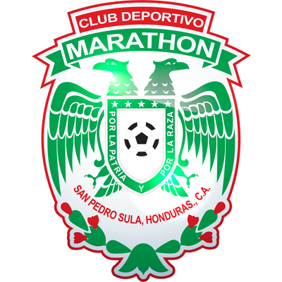 | MARATHON |  | KNOCKOUT STAGES |  | REAL ESTELÍ | 

 | SEPTEMBER 22 |  | 10 PM ET |  | Metropolitan Olympic Stadium

DATA

CD MARATHÓN vs. REAL ESTELÍ
They will meet for the first time in the Scotiabank Concacaf League.
To date, 6 matches have been played between clubs from Honduras and Nicaragua in the SCL.
Honduran clubs are undefeated with 4 wins and 2 draws (14GF-5GA).
Managua vs. Motagua (R16 2019), Managua vs. Olimpia (R16 2020), Motagua vs. Real Estelí (SCCL Repechage in 2020), Diriangén vs. Marathón (Preliminary Round 2021).
It will be the 13th match at the Estadio Olímpico Metropolitano in San Pedro Sula.
Olimpia, Real España, Marathón and Motagua played at home in that stadium where 26 goals were scored (never managed to score more than one goal per game).
The home teams have 5 wins, 1 away win and 6 draws. Santos de Guápiles in the 2017 final vs CD Olimpia was the only team to achieve a win (0-1). Marathón has played 3 times at home and never lost (1W-2T): 1-1 vs. Comunicaciones (Preliminary Round 2019), 1-1 vs. Antigua (R16 2019) and 2-1 vs Diriangén (Preliminary Round 2021).
 | MARATHÓN (HON)
FOUNDED: 1925.
COACH: Martín García (URU).
PARTICIPATIONS: 3 (2019, 2020 and 2021).
RECORD: GP-7 W-3 T-2 L-2 (GF-7 GA-7).
TOP SCORERS: Edwin Solano (HON) with 2, Yustin Arboleda, Allan Banegas, Mario Martínez, Frelys López and Kervin Arriaga (1 c/u).
ASSISTS: Mario Martinez (HON) with 2.
SAVES IN THE SCL 2021: (5). GOALKEEPERS: Denovan Torres (HON) with 5.
SAVES IN TOTAL IN THE SCL : (14). GOALKEEPERS: Denovan Torres (HON) 10 and Luis Ortiz (HON) 4.
PENALTY DEFINITIONS: (1). WON: 1. LOST: 0.
- Won 4-3 vs. Antigua (GUA) in the 2020 SCL Knockout Stages after drawing 1-1 in regulation time.
TOP PLAYERS:
- Mario Martinez (HON). He scored a free-kick goal in the first leg of the Preliminary Round vs. Diriangén and was the player with the most shots (5) and fouls received (8) in the series. Martínez has played in three editions of the SCL: 2018 (Real España), 2019 and 2021 (Marathón).
- Carlo Costly (HON). He was champion in the SCL 2017 with CD Olimpia where he scored 4 goals in 6 matches. With Marathón, he has played in 3 matches (2019 and 2021).
 | REAL ESTELÍ (NCA)
FOUNDED: 1960.
COACH: José Luis Trejo (MEX).
PARTICIPATIONS: 4 (2017, 2019, 2020 and 2021)
BEST RESULT: 4th of Final 2020.
RECORD: GP-7 W-3 T-1 L-3 (GF-7 GA-7).
TOP SCORERS: Juan Ramón Barrera (NCA) 3 goals, Nahum Peralta, Lucio Barroca, Jorge Betancur and Fernando Mercado 1 each.
ASSIST: Brandon Ayerdis (NCA) with 2. In addition, Josué Quijano, Carlos Chavarría and Luis Alberto Acuña (1) attended.
SAVES IN THE SCL: (7). GOALKEEPERS: Henry Maradiaga (NCA) 7.
PENALTY DEFINITIONS: (2). WON: 1. LOST: 1.
- Victory 4-2 vs. Motagua (HON) after drawing 2-2 in the Repechage to qualify to the Scotiabank Concacaf Champions League 2021 at the National Stadium.
- Defeat vs. Águila (SLV) 3-4 after drawing 1-1 in the Knockout Stages in 2017 at the Estadio Independencia.
THIS IS HOW THEy QUALIFIED TO THE SCL 2021: Champion of the Apertura 2020 of the 1st Division of Nicaragua and best record accumulated in the 2020/21 Season. He advanced directly to the 2021 SCL Knockout Stages.
TOP PLAYERS:
- Brandon Ayerdis (NCA). He played four matches in the SCL between (2019 and 2020) with Real Estelí. With Nicaragua he played in CNLQ 2018/19, CNL 2019/20 and the Concacaf qualifiers for the FIFA World Cup Qatar 2022.
- Josué Quijano (NCA). He has 27 international appearances with Real Estelí. He has played 7 matches in the SCL in (2017, 2019 and 2020) and with Nicaragua in the 2017 and 2019 Concacaf Gold Cup.

